INDIAN INSTITUTE OF TECHNOLOGY

KHARAGPUR

APPLIED COMPUTATIONAL METHODS LABORATORY

LAB – 7 Report

Rajiv Harlalka

20MA20073

Department of Mathematics

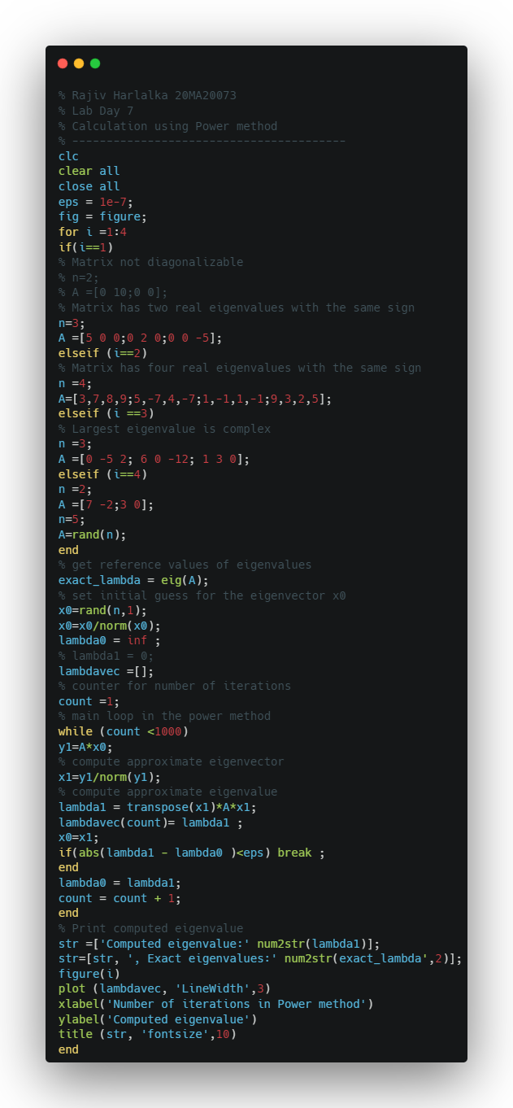Power Method

* Code:
* 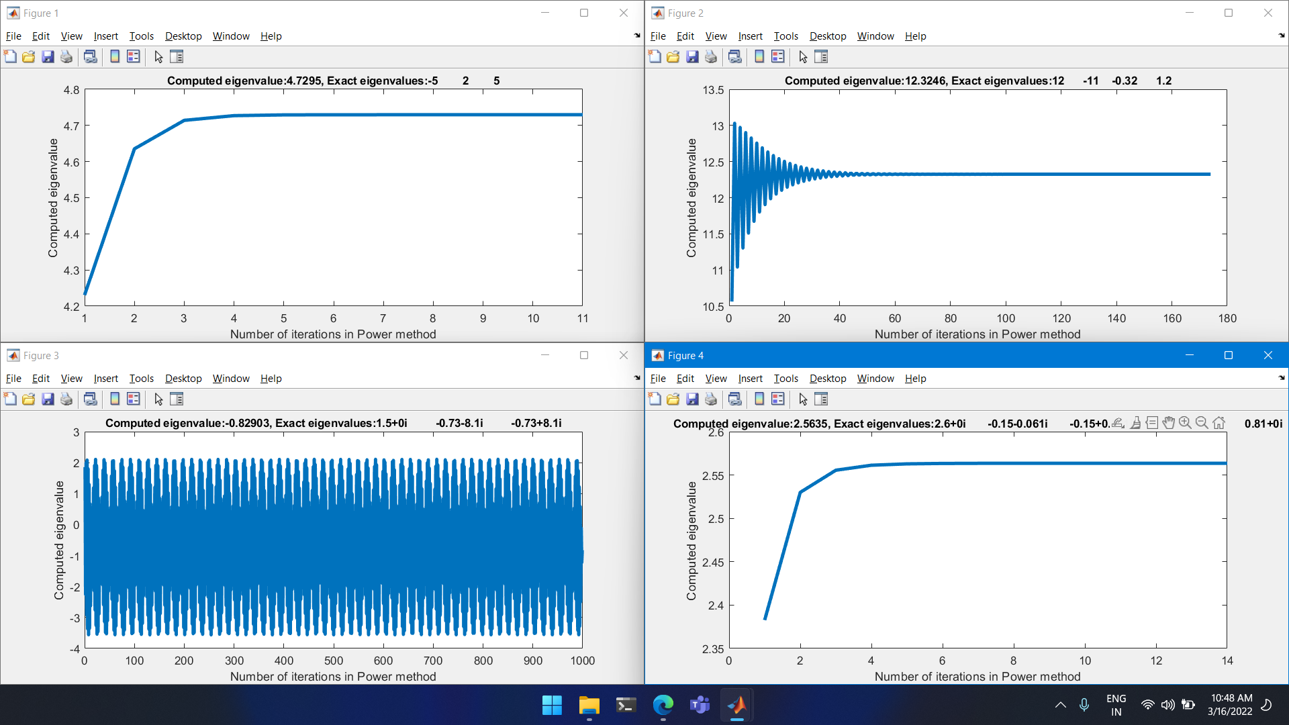Output

Inverse Power Iteration method

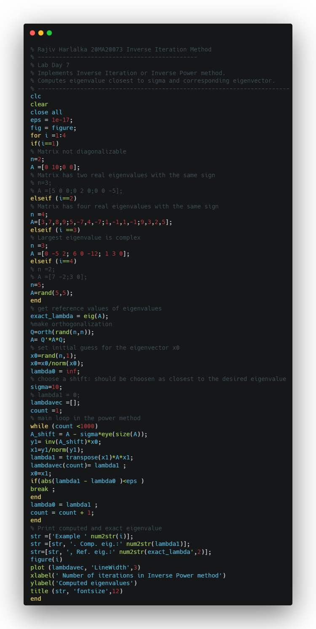Code:

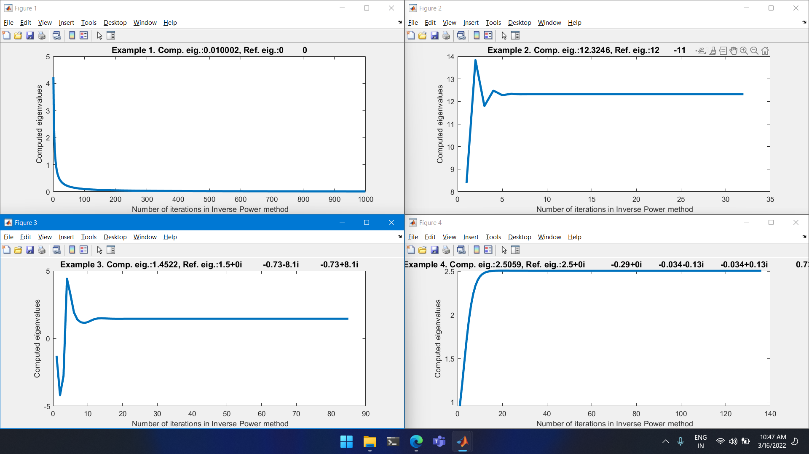Output: